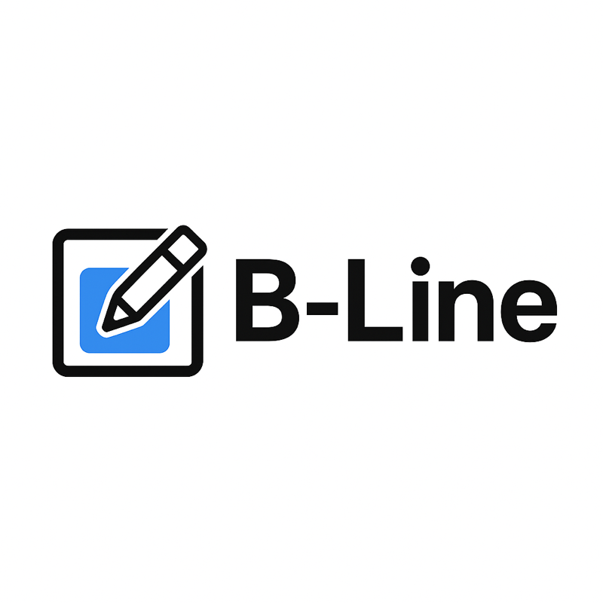
Community-driven storyboard software
Open-source storyboard tool with AI script breakdown, drawing layers, and camera keyframes.

Intro (5 min)
Goal
Requests
Community
Invite community members to suggest code changes and test betas
Available September

Overview
Open-Source Storyboard Tool Overview
AI script breakdown
Timeline with snapping
Linear editing – storyboard track
Non liner editing – audio track
Paint Area
Layers
Camera keyframes
Panel drawing
key bindings

Feature Modes
- Paint
- Stroke Selection
- Camera
- Layers
- Vector Curve Editing
Twitch page gamefusion3d
GitHub page gamefusion/B-Line

Next steps

Next stream content: Live Demos: Building a Storyboard from Scratch
Walkthrough real workflows
- Script import – demo ai
- Create panels
- Draw layout
- Using and animating layers
- Create & Animate Cameras
- Edit panel timing
- Edit audio

